Check the version of browser.

Chrome above 38

Firefox above 37

Safari above 7.1

If you only need to compile queryServlet.java

1. Open a terminal and change path.

*cd $CATALINA_HOME/webapps/queryElastic/WEB-INF/classes*

2. Compile .java file

*javac –cp ‘../lib/*’ queryServlet.java*

1

3. Type in following URL and run the visualization.

<http://localhost:8080/queryElastic/servlets/socialVis/socialVis.html>

If you need to deploy the whole stack from sketch

1. Check Java version

Open terminal and copy following line.

*java -version*

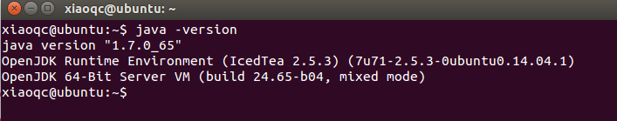

2. Download Tomcat 8.0

<http://mirror.sdunix.com/apache/tomcat/tomcat-8/v8.0.20/bin/apache-tomcat-8.0.20.tar.gz>

3. Extract the download file

*cd <path to download folder>*

*tar -xzvf apache-tomcat-8.0.20.tar.gz*

4. Set environment variables

*export JAVA_HOME=<path to jdk>*

*export CATALINA_HOME=<path to tomcat>*

5. Run tomcat

*$CATALINA_HOME/bin/startup.sh*

6. Test tomcat

Try <http://localhost:8080/> in your browser.

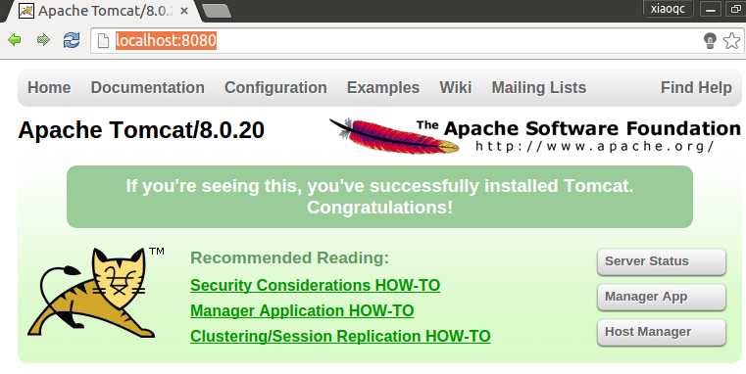

7. Deploy Java servlet

Copy the folder of “queryElastic” from Github

<https://github.com/usc-isi-i2/Social-Viz/tree/master/src/socialVis/Tomcat/>

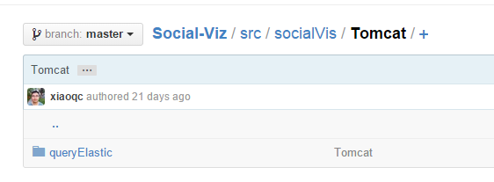

1) Put the folder under tomcat /webapps

2) Open a terminal and change path:

*cd $CATALINA_HOME/webapps/queryElastic/WEB-INF/classes*

3) Compile .java file

*javac –cp ‘../lib/*’ queryServlet.java*



It will generate several .class files.

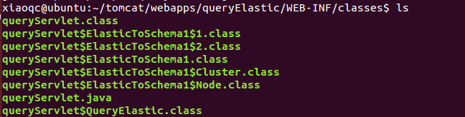

8. Try the webpage

Run the following lines in terminal to restart tomcat.

*$CATALINA_HOME/bin/shutdown.sh*

*$CATALINA_HOME/bin/startup.sh*

Put this URL to your browser.

<http://localhost:8080/queryElastic/servlets/socialVis/socialVis.html>

Write query on the left panel.

Start Date: 2014-07-01

End Date: 2014-07-31

MaxNode: 50

Click search button.

Wait for tens of second to retrieve data.

Then visualization will be shown.

